Reuben Monroe Wynn
October 21, 1869 – June 30, 1943

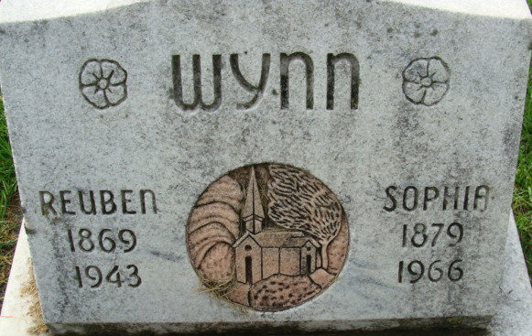
Photo by Alicia Kneuss

Ruben M Neynn
in the Indiana, Death Certificates, 1899-2011
Name: Ruben M Wynn
Gender: Male
Race: White
Age: 73
Marital status: Married
Birth Date: 21 Oct 1869
Death Date: 30 Jun 1943
Death Place: Decatur, Adams, Indiana, USA
Father: David Wynn
Mother: Elizabeth Curtis
Spouse: Sophia
Informant: R. O. Wynn; Decatur, Ind.
Burial: July 3, 1943; Decatur Cem., Decatur, Ind.

