Marie (Clowser) Wynn
April 4, 1897 – July 12, 1987

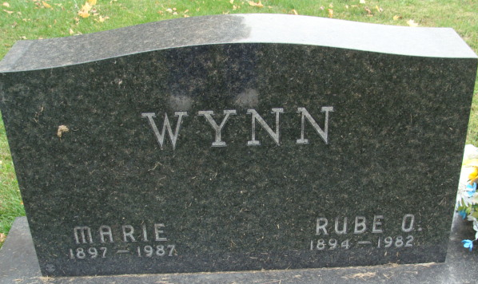
Photo by Alicia Kneuss

Marie C Wynn
in the Indiana, Death Certificates, 1899-2011
Name: Marie C Wynn
[Marie C Clowser]
Gender: Female
Race: White
Age: 90
Marital status: Widowed
Birth Date: 4 Apr 1897
Birth Place: Indiana
Death Date: 12 Jul 1987
Death Place: Decatur, Adams, Indiana, USA
Father: John Clowser
Mother: Ida Richey
Informant: David C. Wynn; son; Decatur, Ind.
Burial: July 15, 1987; Decatur Cem., Decatur, Ind.

