Kathryn V. (Hill) Wynn
February 25, 1917 – April 9, 2013

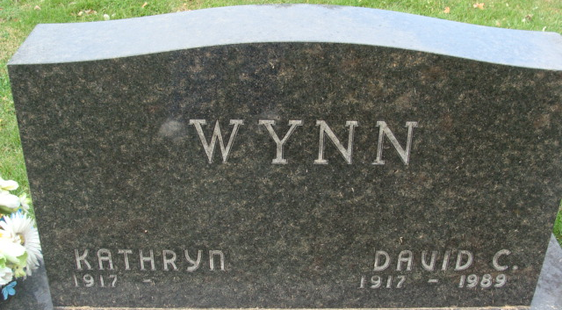
Photo by Alicia Kneuss

Kathryn V. Wynn, 96, of Decatur died Tuesday, April 9, 2013 at Adams Memorial Hospital. Kathryn was born on February 25, 1917 in Adams County, IN to the late George W. and Clara J. (Mauller) Hill. On September 25, 1938 she married David C. Wynn; he preceded her in death on October 24, 1989.
Kathryn was a member of St. Mark's United Methodist Church. She was a member of the Builders Sunday School class, the United Methodist Women and was also of the Decatur Order of Eastern Star #127. She was a homemaker.
Survivors include a son David A. Wynn of Berne, IN; a daughter Eunice J. Wynn of Decatur, IN; four grandsons; two step grandchildren and 6 great grandchildren. She was preceded in death by a daughter Kay Affolder, Nov. 10, 1975 and a daughter-in-law Jana Wynn, December 19, 2011.
Visitation will be from 10:00-11:00 a.m. Thursday, April 11, 2013 at Woodcrest Porter Auditorium and from 3:00-7:00 p.m. at Haggard-Sefton & Hirschy Funeral Home. Family will receive friends from 9:30 -10:30 a.m. prior to services at the church on Friday.
Funeral service will be at 10:30 a.m. on Friday, April 12, 2013 at St. Mark's United Methodist Church. Rev. Michael Heinbaugh officiating and burial will be in Decatur Cemetery.

Haggard & Sefton Funeral Home, Adams County, Indiana
April 10, 2013

