Jana L. (Hendricks) Wynn
March 7, 1946 – December 19, 2011

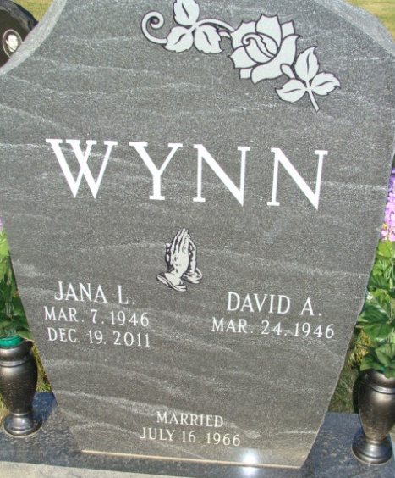
Photo by Alicia Kneuss

Jana L. Wynn, 65, of Berne, passed away on Monday, December 19, 2011, at Swiss Village Retirement Community in Berne. Jana was born on March 7, 1946, in Adams County to the late Charles C. and Nolda G. (Agler) Hendricks. On July 16, 1966, she married David A. Wynn.
Jana was a member of St. Mark's United Methodist Church in Decatur and a former choir member. She was also a homemaker.
Surviving are her husband, David A. Wynn of Berne; two sons, Michael D. and Mark D. (Jolene) Wynn, both of Berne; a brother, Dean E. (Myrna) Hendricks of Berne; and four grandchildren: Nathan, Megan, Brandon, and Kristen Wynn all of Berne.
Visitation is 2-8 p.m. on Wednesday, December 21, 2011, at Haggard-Sefton and Hirschy Funeral Home, Decatur and one hour prior to services at the church. The funeral service will be held at 10:30 a.m. on Thursday, December 22, 2011, at St. Mark's United Methodist Church, with Pastor Michael Heinbaugh officiating. Burial will be in Decatur Cemetery.
Memorials are to St. Mark's United Methodist Church's music department.

Decatur Daily Democrat, Adams County, Indiana
Tuesday, December 20, 2011

