Iona Wynn
August 8, 1897 – November 24, 1906

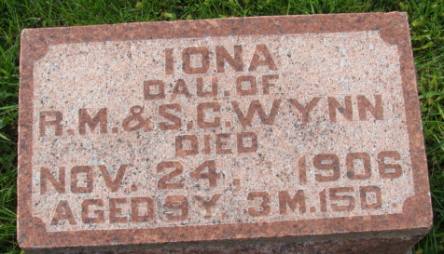
Photo by Alicia Kneuss

LITTLE IONA WYNN IS DEAD
Lived Here Until Recently When Parents Moved to Huntington

Little Iona Wynn, daughter of Mr. and Mrs. Reuben Wynn of 11 West Sabine Street, died Saturday morning about 1 from an attack of pneumonia. She had been sick about two weeks, but her condition was not regarded serious until Friday evening. She was about nine years old.
Her father was at work at the Erie Shops, where he had been working since the family moved here from Adams County last July. He was called home during the evening when her condition became dangerous.
Besides the mother and father there are left two brothers and two sisters to mourn the death of the little playmate.
The funeral was held at the residence on Sabine Street Sunday afternoon. Rev. Cephas Shelburne officiated. Mrs. F. W. Grayston and Mrs. J. L. Stewart furnished the music. Flowers were in charge of Misses Gladys Miller and Helen Booth.
Pall bearers were playmates, Misses Hilda Blynn, Florence Ertzinger, Blanch Braughton and Esther Schenekl. – Huntington News-Democrat
The Wynn family lived here until a few months ago, and little Iona was a favorite among those who knew her.

Decatur Democrat, Adams County, Indiana
(a weekly newspaper)
Thursday, November 29, 1906

**
Indiana, Death Certificates, 1899-2011
Name: Iona Wynn
Gender: Female
Race: White
Age: 9
Marital status: Single
Birth Date: 8 Aug 1897
Birth Place: Adams Co-Ind
Death Date: 24 Nov 1906
Death Place: Huntington, Huntington, Indiana, USA
Father: Rheuben M Wynn
Mother: Sophia Gross
Burial: Nov. 25, 1906; Mt. Hope

