David C. Wynn
January 14, 1917 – October 24, 1989

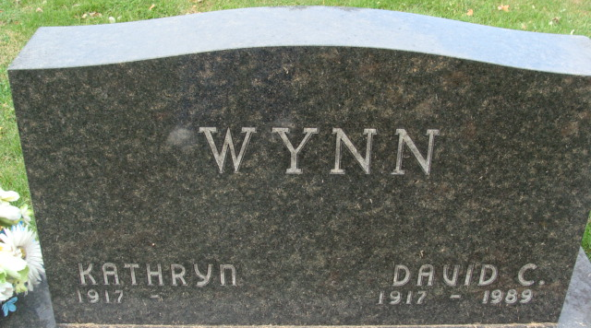
Photo by Alicia Kneuss

David C Wynn
in the Indiana, Death Certificates, 1899-2011
Name: David C Wynn
Gender: Male
Race: White
Age: 72
Marital status: Married
Birth Date: 14 Jan 1917
Birth Place: Dixon Illinois
Death Date: 24 Oct 1989
Death Place: Decatur, Adams, Indiana, USA
Father: Rube O Wynn
Mother: Marie Clowser
Spouse: Kathryn Hill
Informant: Kathryn (Hill); wife; Decatur, Ind.
Burial: Oct. 27, 1989; Decatur Cem., Decatur, Ind.

