David A. Wynn
March 24, 1946 – December 24, 2017

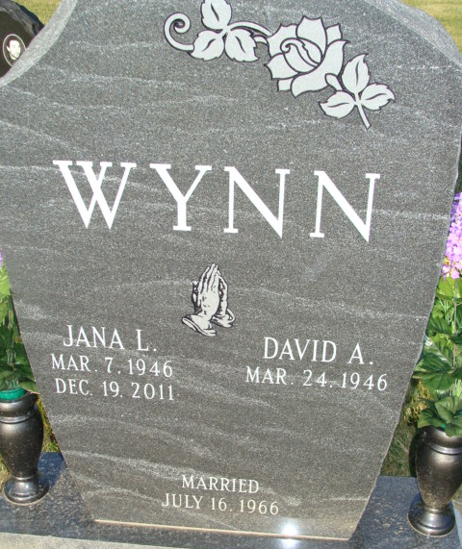
Photo by Barbara Baker Anderson

David A. Wynn, 71, of Berne, Indiana, passed away at his residence on Sunday, December 24, 2017. David was born on March 24, 1946 in Decatur to the late David C. and Kathryn V. (Hill) Wynn. On July 16, 1966, he married Jana L. Hendricks; she preceded him in death on December 19, 2011.
David was a member of St. Mark’s United Methodist Church, where he sang in the church choir and served on several committees. He was also a member of the Decatur Masonic Lodge 571 F.&A.M. David retired in 2007 as a Cell leader at C.T.S.
He is survived by his two sons, Michael D. Wynn and Mark D. (Jolene) Wynn both of Berne; a sister Eunice J. Wynn of Decatur; four grandchildren, Nathan, Megan, Brandon and Kristen Wynn. He was preceded in death by a sister, Kay Marie Affolder.
Visitation will be from 2:00-8:00 p.m. Thursday, December 28, 2017 at Haggard-Sefton & Hirschy Funeral Home. Funeral Service will be held at 10:30 a.m. Friday, December 29, 2017 at St. Mark’s United Methodist Church with calling 1 hour prior from 9:30-10:30 a.m. Pastor Jeff Taylor and Pastor Ernie Suman will be officiating and burial will be in Decatur Cemetery.
Memorials are to St. Mark’s Music Department.

Haggard-Sefton & Hirschy Funeral Home, Adams County, Indiana
December 26, 2017

