Mary Ann (Bowser) Wyatt
March 10, 1846 – September 21, 1900

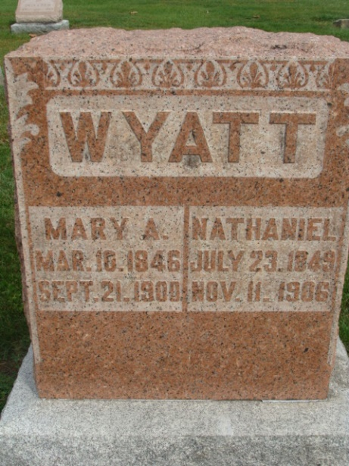
Photo by Alicia Kneuss
Mrs. Nathaniel Wyatt died very suddenly at her home on North Fifth Street, in this city, Friday evening, from an attack of paralysis of the heart.
The funeral services were conducted from the U. B. Church Sunday afternoon at 3 o'clock. Mary Ann Bowser was born in Allen County, Indiana, March 10, 1846. Departed September 21, 1900, aged 54 years, [sic] 11 days, having received her third stroke of paralysis.
She was converted at the age of 14, at which time she joined the United Brethren Church, and has remained a faithful member ever since, never faltering, never wavering through the severest trials. Her girlhood days were spent with her parents on a farm near Fort Wayne.
On August 16, 1872, at the age of 26, she was united in marriage to Nathaniel Wyatt, to whom she was a faithful and devoted companion. To this happy union were born five children, two boys and three girls, all of whom are left to mourn her departure. She was truly a mother in every sense of the word. When her children were very young she taught them to follow Christ. Her foremost care and thought were of them, but now without her, home will be incomplete. She was always faithful to her church when it was at all possible, often going when scarcely able to be on her feet.
February 19, 1879, while at her post of duty in this church, she received her second stroke of paralysis. This caused her to be helpless ever since. She could walk only with the greatest difficulty, but would often walk to the neighbors, thinking the exercise would soon give her back her former health. Before her stroke her daily companions were her song book and Bible. Until this affliction, singing had been to her a source of greatest comfort and consolation. "It is well with my soul," and "I will sing you a song of that beautiful land," expressed her belief in the happiness and joys of the future life. The Bible was most truly her guide book to this heavenly land of which she so often sweetly sung. The sorrows and difficulties of life were to her made endurable, yea, blessed by the promise of His word. On the last day of her life, she said to her daughter, Ella, tired and discouraged, "If you remember His promises in the 14th chapter of John, you could be happy although the way may seem hard." No day passed without her reading the Bible, and prayer was her daily strength. In the morning worship of the family, she always led. When the prayer meeting bell rang, she always wished she might go to God's house, as she had always done when she had health.
She leaves a husband and five children to whom home without "mother" will seem almost barren. In the last years her affections have called for un-ceased care and love, and how much she will be missed cannot be expressed. Although her sufferings were almost unbearable, she bore them with fortitude, often silently. Six sisters and one brother remain to mourn their loss. Her family and friends, although left to sorrow, are comforted in the promises of Christ: "Where I am there ye may be also, and I go to prepare a place for you." Scripture lesson, 2d Corinthians, 5th chapter, 1st to the 11th. Phil., 1st chapter, 20th to 28 verse; Text, Phil., 1st chapter, 23d to 24th verse.
The funeral was largely attended.

Decatur Democrat, Adams County, Indiana
(a weekly newspaper)
Thursday, September 27, 1900
**
Indiana, Death Certificates, 1899-2011
Name: Marry Ann Wayett
[Marry Ann Bowser]
Gender: Female
Race: White
Age: 54 years, 6 months, 11 days
Marital status: Married
Birth Date: abt 1846
Birth Place: Allen Co Ind
Death Date: 21 Sep 1900
Death Place: Decatur, Adams, Indiana, USA
Father: Daniel Bowser
Mother: Jane Waters
Informant: Nathaniel Wayett; Decatur, Ind.
Burial: Sept. 23, 1900; Maplewood Cem.

