Vera Arvesta (May) Wright
July 28, 1905 – November 21, 1925

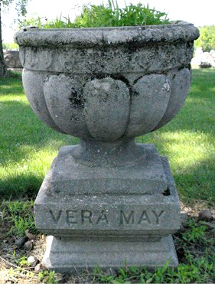
Photo by Barbara Baker Anderson

Vera Arresta Wright
in the Indiana, Death Certificates, 1899-2011
Name: Vera Arvesta Wright
Maiden Name: May
Gender: Female
Race: White
Age: 20
Marital status: Divorced
Birth Date: 28 Jul 1905
Birth Place: Adams Co. Ind
Death Date: 21 Nov 1925; sepsis contributed by abortion
Death Place: Ft. Wayne, Allen, Indiana, USA
Father: Nelson H. May
Mother: Alice Carpenter
Spouse: Dean Wright
Informant: Mrs. Pearl Bollinger; Decatur, Ind.
Burial: Nov. 23, 1925; Decatur Cem.

