Silas L. Woy
August 22, 1852 – November 6, 1860

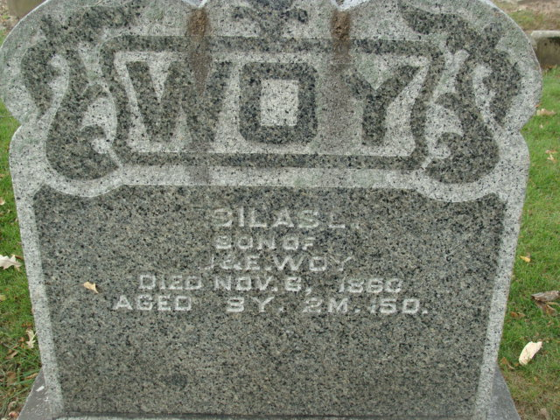
Photo by Alicia Kneuss

No further information has been found

