Hannah (Bonebrake) Woy
October 27, 1834 – March 3, 1903

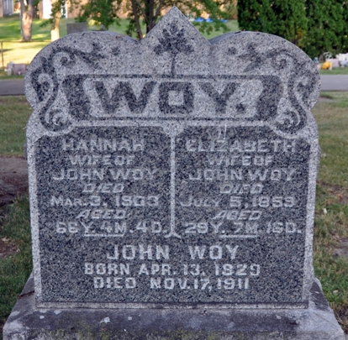
Photo by Barbara Baker Anderson

THE GRIM REAPER
Death of Pioneer Lady This Morning
Mrs. John Woy Answers the Final Call after Long and Useful Life
Mrs. John Woy died at 6 o'clock this morning at her home on North Fifth Street. She has been in rather poor health for a long time, but seemed no worse until yesterday morning, when alarming symptoms became apparent. She sank rapidly until this morning when death resulted. She was one of the best known ladies in the county, having lived here for over forty years, and made friends with all who met her.
She was born in Carrol County, Ohio October 27, 1834, and resided there until 1860, when she was married to John Woy, and removed to this county, having since resided in the vicinity of Decatur. She was nearly seventy years of age.
No children survive, and the near relatives, besides the husband, are five sisters: Mrs. Jackman, of Whiting, Kansas; Mrs. Martin of New London, Iowa; Mrs. Lavina, Mrs. Laticia and Miss Quarry, of Stark County, Ohio.
Mrs. Woy's death was due directly to LA grippe and heart trouble, which, owing to her weakened conditions, seemed to take a terrible hold.
No arrangements have yet been completed for the funeral, nor will be until the arrival of her sisters tomorrow.
Daily Democrat, Adams County, Indiana
Tuesday, March 3, 1903

