Ryan Lindsey Woten
September 5, 1980 – September 5, 1980

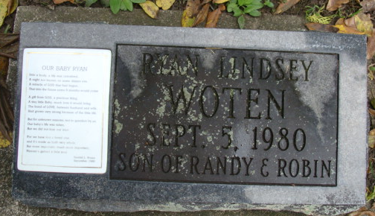
Photo by Alicia Kneuss

No further information found at this time

