Robert K. Worthman
November 19, 1919 – May 27, 2001

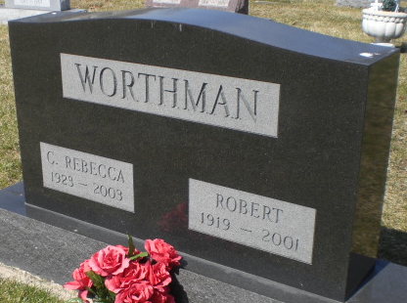
Photo by Alicia Kneuss

Robert K. Worthman, 81, of Decatur, a former deacon at Zion United Church of Christ, died Sunday, May 27, 2001, at Lutheran Hospital, Fort Wayne.
The Decatur native graduated from Ball State University, where he played three years of varsity football, and then received his master's degree from Indiana University. He taught and coached at several local high schools and retired from North Adams Community Schools as a former coach, teacher and athletics director. In 1982, Bellmont High School football stadium was dedicated Bob Worthman Stadium in his honor. He was also presented with a Sagamore of the Wabash award in 1982. Mr. Worthman was inducted into Indiana Football Hall of Fame and named Athletics Director of the Year, both in 1989. He was a member of Elks Lodge 993, Masonic Lodge 371, and a 50-year member of Decatur Lions Club.
Surviving is his wife, C. Rebecca, and his niece, Linda Green of Hoagland.
Services are 11 a.m. Thursday at Zion United Church of Christ, with calling one hour before services. Calling will also be from 2 to 5 and 6 to 8 p.m. Wednesday at Zwick & Jahn Funeral Home, Decatur. Burial will be at Decatur Cemetery.
Memorials are to the church, The Worthman Grant or to donor's choice.
News-Sentinel, Allen County, Indiana
Tuesday, May 29, 2001
**
Indiana, U.S., Death Certificates, 1899-2017
Name Robert K Worthman
Gender Male
Race White
Marital Status Married
Age 81
Birth Date 19 Nov 1919
Birth Place Decatur, Indiana
Death Date 27 May 2001
Death Place Fort Wayne, Allen, Indiana, USA
Death Registration Date 2001
Father Martin Worthman
Mother Lydia Fruchte
Spouse C Rebecca Walters
Informant C. Rebecca Worthman; wife; Decatur, Indiana
Burial May 31, 2001; Decatur Cemetery; Decatur, Indiana

