Paul Edward Worthman
September 11, 1911 – September 15, 1911

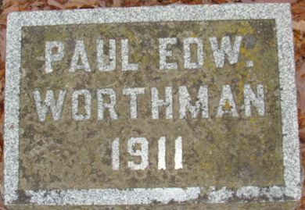
Photo by Alicia Kneuss

Paul
Born Sept. 11, 1911; died Sept. 15, 1911 from mother's obit
**
Paul Edward Worthmann from tree Kirsch-Hans
Birth 1911
Death 1911
Father Edward L. Worthman (Born 1886)
Mother Emma R. Mutschler (1887-1911)

