Emma R. (Mutschler) Worthman
January 15, 1887 – October 6, 1911

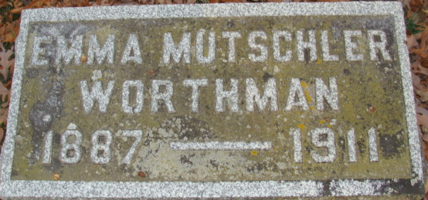
Photo by Alicia Kneuss

DEATH CAME TODAY
Emma, Wife of Rev. Edward Worthman, Passed Away This Afternoon
AT THEIR HOME
In Kaukauna, Wis. - Daughter of Mr. and Mrs. Fred Mutschler of This City
Following closely a message received this morning that she was not expected to live until night, came a message this afternoon at 2:40 o’clock to Fred Mutschler of this city that his daughter, Emma, wife of the Rev. Edward Worthman, of Kaukauna, Wis., had passed away at 2 o’clock this afternoon at her home there. September 11th a babe was born to the Rev. and Mrs. Worthman, the babe dying four days later. Mrs. Worthman did not recover as she should and grew worse from week to week.
A letter coming Thursday stated that she was better and hope became greater, but a card this morning stated that she was worse, then a telegram that she could not live till night, the later telegram bringing the message of her death. Her mother, who has been with her daughter since the death of the babe, was with her at the time of her death, and with the bereaved husband will accompany the body here, they expecting to arrive tomorrow afternoon over the Erie railroad at 2 o'clock.
Miss Emma Mutschler was one of the most beloved and popular young girls of the city, and was married a year ago last September 28th. to the Rev. Edward Worthman of Magley, a young minister of the German Reformed church, they going at once to his charge at Kaukana, Wis., where they have resided since. Had she lived until next January 15th, Mrs. Worthman would have been twenty-five years of age.
She leaves besides the husband her parents, two sisters -Emma and Huldah, and two brothers - Albert and Edgar. The brother, Albert, is now in Portland, Oregon, and will be notified of her death at once.
Decatur Daily Democrat; Adams County, Indiana
Friday, October 6, 1911

**
Emma R Mutschler from tree Leible Stammbaum
Birth 15 Jan 1887 Indiana, USA
Marriage 27 Sep 1910 Allen, Indiana, USA
Residence 1910 Adams, Indiana, USA
Death 1911
Father Friedrich Heinrich Mutschler (1864-1933)
Mother Katherine Eva Kirsch (1867-1917)
Spouse Edward L Worthmann (Born 1885)

