Celia Rebecca (Walters) Worthman
May 16, 1923 – January 6, 2003

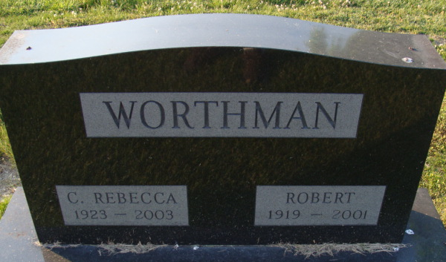
Photo by Alicia Kneuss
C. Rebecca Worthman, 79

A retired teacher, C. Rebecca “Becky” Worthman, 79, of Decatur died at 1:36 am Monday, January 6 at Adams County Memorial Hospital in Decatur following an extended illness.
Mrs. Worthman retired in 1983 after 37 years in her teaching career. She was a former teacher and guidance counselor at Decatur High School and at Bellmont High School.
She earned her BS degree in physical education and English at Ball State College in 1946 and later her master’s degree in guidance counseling at St. Francis College in Fort Wayne.
Mrs. Worthman was a member of Zion United Church of Christ, member and past president of Kappa Kappa Kappa and the Adams County Retired Teachers Association.
She was born in Kendallville May 16, 1923 to Charles J. and Hallie Bennett Walters. Her marriage on July 16, 1953 was to Robert K. Worthman, who died May 27, 2001.
Surviving are a brother, John E. Walters of Lathrup Village, Michigan and several nieces and nephews. A brother and two sisters are deceased.
Services will be at 1 pm Thursday at the Zwick and Jahn Funeral Home in Decatur with Rev. Randy Rossman officiating. Burial will be in Decatur Cemetery. Calling hours at the funeral home will be Wednesday from 2 to 4 and 6 to 8 pm.
Memorials to Zion United Church of Christ, to Worthman Grant, or to donor’s choice.

Bluffton News-Banner, Wells County, Indiana
January 7, 2003

**
C. Rebecca "Becky" Worthman, 79, of Decatur, a former teacher/guidance counselor at Decatur and Bellmont high schools, died Monday, Jan. 6, 2003, at Adams County Memorial Hospital.
The Kendallville native retired in 1983 after 37 years of service, and was a member of Zion United Church of Christ and Retired Adams County Teachers Association. She was past president of Kappa Kappa Kappa.
Surviving are a brother, John E. Walters of Lathrup Village, Mich.; and several nieces and nephews. She was preceded in death by her husband, Robert K., sisters, Jean Baker and Norma Doyle and a brother, Robert Walters.
Services are 1 p.m. Thursday at Zwick & Jahn Funeral Home, Decatur, with calling from 2 to 4 and 6 to 8 p.m. Wednesday. Burial will be at Decatur Cemetery.
Memorials are to the church, Worthman Grant or donor's choice.

News-Sentinel, Allen County, Indiana
Tuesday, January 7, 2003

