Floyd Mainard Worley
December 13, 1882 - 1963

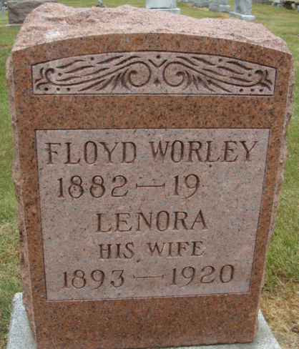
Photo by Alicia Kneuss

Floyd Worley
in the U.S., Social Security Death Index, 1935-2014
Name Floyd Worley
Social Security Number xxx
Birth Date 13 Dec 1882
Issue year Before 1951
Issue State Indiana
Death Date Jun 1963
**
Floyd Mainard Worley from tree Dreier
Birth 13 Dec 1882 Paulding, Ohio, USA
Marriage 25 Mar 1913 Lake, Indiana, USA
Death Jun 1963 Indiana, USA
Father William M. Worley (1852-1924)
Mother Mary Lucinda Haines (1861-1920)
Spouse Lenora P. Cassaday

