William D. Workinger
January 17, 1933 – February 24, 1988

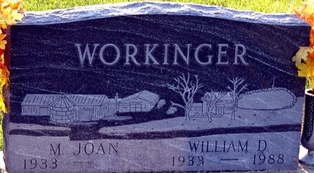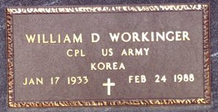
Photo by Deb Curry
William D. Workinger, 55, route 7, Decatur, well-known St. Mary's Township farmer, died at 12:40 a.m. today at Adams County Memorial Hospital, where he had been hospitalized since Sunday. He had been in failing health the last four weeks.
Mr. Workinger, a bus driver for the Adams Central school district for a dozen years, was a member of the board for the Adams County Farm Bureau Co-op. He attended Pleasant Mills United Methodist Church and was a member of Decatur Masonic Lodge 571 F&AM, Adams County Shrine Club, Scottish Rite, Adams County Calliopers, and the Mizpah Shrine. He was also a veteran of the Korean conflict.
Born in Ft. Wayne on Jan 17, 1933, he was a son of Harry S. and Zelma Black-Workinger and was married to Joan Riley Dec 30, 1951 in Pleasant Mills.
Survivors include the wife; the mother, of route 7; five children, Mrs. David (Sharon) Fisher, route 1, Monroe; Mrs. Janet Haines, Daniel Workinger, Mrs. Ked (Lori) Snyder and Miss Micki W. Workinger, all of route 7, Decatur; a brother, Robert D. Workinger, Decatur, a former Adams County commissioner.
Services will be held at 10:30 a.m. Saturday in Zwick-Sefton & Jahn Funeral Home, Rev. Ersel Potts officiating. Burial will be in Decatur Cemetery. Friends may call at the funeral home from 7-9 p.m. Thursday and 2-5 and 7-9 p.m. Friday. Masonic services will be held at 7 p.m. Thursday.
Memorials are to Pleasant Mills United Methodist Church or Shriners Hospitals.
Decatur Daily Democrat, Adams County, Indiana
Wednesday, February 24, 1988
**
WILLIAM D. WORKINGER
Services for William D. Workinger, 55, route 7, Decatur, who died Wednesday, will be held at 10:30 a.m. Saturday at Zwick-Boltz & Jahn Funeral Home, where friends may call from 2-9 p.m. today and 2-5 and 7-9 p.m. Friday.
Pallbearers will be Robert Fuhrman, Lester Brunner, John Johnson, Boyd Bienz, Marcus Brodbeck, Ed Schultz, Jack Raudenbush and Billy Johnson.
Survivors include 9 grandchildren who were not listed among the survivors given in the Democrat Thursday.
Decatur Daily Democrat, Adams County, Indiana
Thursday, February 25, 1988

