Ruthey (Drake) Workinger
February 11, 1861 – April 24, 1930

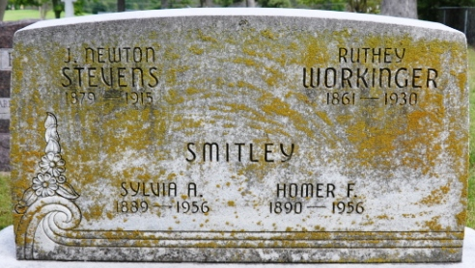
Photo by Deb Curry
Ruthey Warkinger
in the Indiana, U.S., Death Certificates, 1899-2017
Name Ruthey Workinger
[Ruthey Drake]
Gender Female
Race White
Marital Status Widowed
Age 69
Birth Date 11 Feb 1861
Birth Place Ohio
Death Date 24 Apr 1930
Death Place Decatur, Adams, Indiana, USA
Death Registration Date 1930
Father William Drake
Mother Ruthey Walters
Informant Sylvia Smitley
Burial April 26, 1930; Decatur Cemetery

