Robert S. Workinger
October 14, 1911 – March 21, 2005

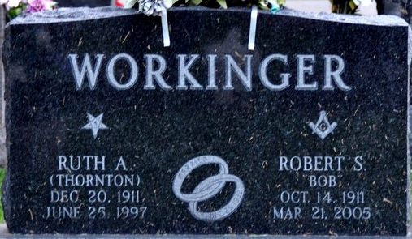
Photo by Deb Curry
Robert S. Workinger 93 of Ionia, Michigan formerly of Decatur, IN passed away at the Heartland Health Care facilities. He was born in Adams County, IN to William & Laura (Barkley) Workinger on October 14, 1911. He then married Ruth A. (Thornton) on Dec. 25, 1932 and she died June 25, 1997.
He has a daughter Mr. Roger (Shirley) Habegger of Portland, Michigan and 2 granddaughters Mrs. John (Sheri) Brundage of Clarkston, MI and Mrs. Paul (Gayle) Coates of Zeeland, MI; 6 great grandchildren Stephanie, Katie, Rachel & Lauren Brundage, Nathan & Kyle Coates. Preceded Robert in death was his wife, a daughter Betty Lou; 2 brothers and 2 sisters.
Robert was the oldest member of the Union Chapel United Methodist Church in rural Decatur. He also was the church treasurer for 21 years and served on most of the offices of the church. He also was members of the Decatur Masonic Lodge #571 F. & A.M. and was past Worshipful Master in 1963; Scottish Rite Valley Ft. Wayne; former member of the Decatur Eastern Star of which he was past Worthy Patron; Decatur Camera Club; Trot-A-Bout travel club; Decatur Optimist Club; Decatur Senior Citizens. He retired from Casad Depot where he was a sign painter for over 30 years.
Visitation will be on Friday, March 25, 2005 from 2-4 & 6-8 pm at Haggard & Sefton and 1 hour prior to services at the church on Saturday. There will also be a Masonic service at 7:00 pm on Friday at the funeral home. Funeral will be at 10:30 am on Saturday, March 26, 2005 at Union Chapel United Methodist Church rural Decatur. Rev. James Patch will be officiating and burial will be in Decatur Cemetery, Decatur, IN.
Haggard & Sefton Funeral Home, Adams County, Indiana
March 22, 2005
**
SSDI: ROBERT S WORKINGER 14 Oct 1911 21 Mar 2005 (V) 48875 (Portland, Ionia, MI) (none specified) xxx Indiana

