Robert D. Workinger
August 30, 1925 – June 24, 1989

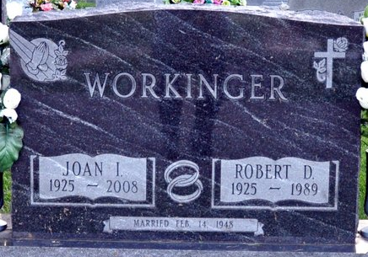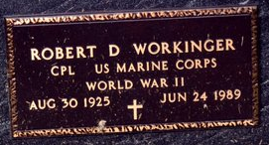
Photo by Deb Curry
Funeral services are scheduled at 11 a.m. Wednesday in St. Mark's United Methodist Church. Revs. James S. Hook and Fuhrman Miller officiating, for three-term Adams County Commissioner and two-term Washington Township Assessor Robert D. Workinger. Mr. Workinger, a resident of 818 N. Third St., died at the age of 63 at 5:45 a.m. Saturday in Lutheran Hospital, Fort Wayne.
Burial will be in Decatur Cemetery, with complete military graveside rites by American Legion Post 43. Pallbearers will be Mayor Fred Isch, Bill Whitright, Jim Inskeep, Dave Shaffer, Mike Ellenberger, Wayne Carpenter, and Bill Carpenter. Members of the Adams County Sheriff's Department will serve as honorary pallbearers.
Visitation is at 2-5 and 7-9 p.m. today and 205 and 7-9 p.m. Tuesday at Zwick-Sefton and Jahn Funeral Home. There will be a Masonic service by the Decatur lodge at 7 p.m. Tuesday.
Mr. Workinger underwent open-heart surgery on April 11 and spent the following seven weeks in the intensive care unit there. He had been showing signs of improvement and death was unexpected.
He was born in Fort Wayne on August 30, 1925 to Harry S. and Zelma W. Black Workinger. The father is deceased; the mother lived on route 7, Decatur. He married the former Joan I. Oliver on February 14, 1948; she survives.
He was a 1943 graduate of Pleasant Mills High School and served in the U.S. Marine Corps in World War II. From 1955-70, he operated the Downton Texaco station at Second and Jefferson Sts., changed the name to Arco, and operated it until 1977, when he went to work for the City of Decatur Water Department.
He was a member of Union United Methodist Church and attended St. Mark's United Methodist Church the past 20 years.
He was a 28 year member of the Adams County Sheriff's Department Reserves and a member of Decatur lodge 571 or F&AM, Eastern Star chapter 127, Scottish Rite, Adams County Shrine Club, and American Legion Post 43. He was a former member of the Decatur Fire Department's volunteers and the Decatur Optimist Club.
Other survivors are one daughter, Mrs. Michael D. (Darlene S.) Reidenbach, 322 N. First St.; one grandson; one granddaughter; and several nieces and nephews. A brother, Bill Workinger died on February 24, 1988.
Preferred memorials are to St. Mark's United Methodist Church, girls' Junior and Senior Leagues, Little League, and boys' Youth League.
Decatur Daily Democrat, Adams Co, Indiana
Monday, June 26, 1989

