Ray Edward Workinger
January 1, 1970 – September 16, 1986

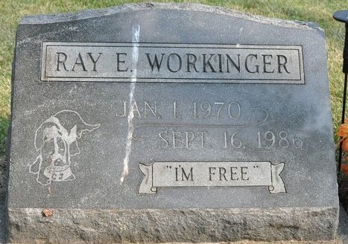
Photo by Deb Curry
Services for Ray E. Workinger, 16, 315 Sprunger St., Berne, who died at 3:15 p.m. Tuesday in Parkview Memorial Hospital, Fort Wayne, will be held Friday at 1 p.m. at Zwick-Boltz & Jahn Funeral Home, Rev. Thomas Chapman officiating. Friends may call at the funeral home from 2-9 p.m. Thursday. Burial will be in the Decatur Cemetery.
The teenager suffered a head wound from a .22 caliber bullet hitting him in the forehead Monday at his home. The shooting incident is still under investigation. He was a junior at South Adams High School and attended Leo High School part of last year, where he was active in track. He worked last summer at Klopfenstein Furniture in Leo.
Born in Albuquerque, N.M., on Jan. 1, 1970, he was the son of Jerry and Nina McAhren-Workinger, who survive. Also surviving are one sister, Mrs. Jack (Annette) Noe, of near Bluffton; a brother, Scott, Los Angeles, Calif.; the paternal grandmother, Mrs. Mildred Workinger, Geneva; and the maternal grandparents, Mr. and Mrs. Raymond McAhren, route 7, Decatur.
Decatur Daily Democrat; Adams County, Indiana
Wednesday, September 17, 1986

