Perry Workinger
October 18, 1876 – February 14, 1966

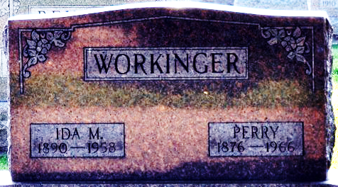
Photo by Deb Curry

Perry Workinger
in the Indiana, U.S., Death Certificates, 1899-2017
Name Perry Workinger
Gender Male
Race White
Marital Status Widowed
Age 89
Birth Date 18 Oct 1876
Birth Place Adams County
Death Date 14 Feb 1966
Death Place Rural, Wells, Indiana, USA
Death Registration Date 1966
Father Samuel Workinger
Mother Margaret Hilyard
Informant Leo Workinger; son; Decatur, Indiana
Burial February 17, 1966; Decatur Cemetery; Decatur, Indiana

