Nina M. (McAhern) Workinger
February 3, 1943 – December 16, 2021

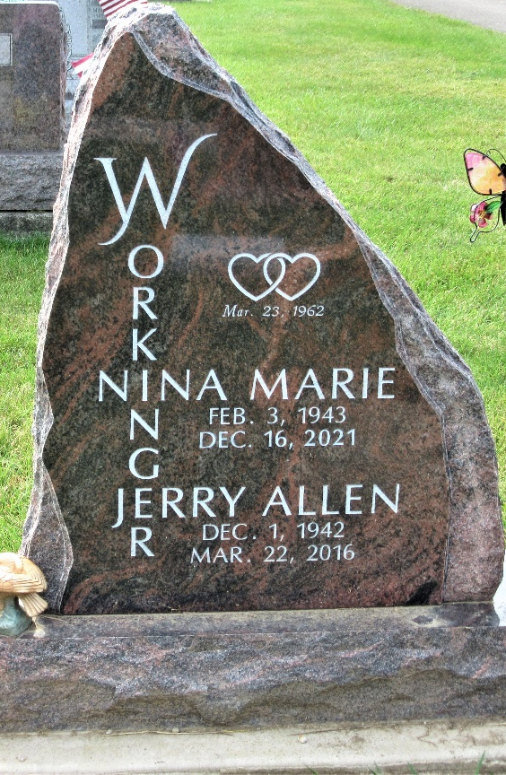
Photo by PLS

Nina M. Workinger, 78, of Oklahoma City, Oklahoma, went to her heavenly home on Thursday evening, December 16, 2021 at Norman Regional Hospital in Norman, Oklahoma. Nina was born on February 3, 1943 in Ossian, Indiana to the late Raymond and the late Delila (Adams) McAhren. She was married to her sweetheart, Jerry, on March 23, 1962 at Decatur Nazarene Church. He preceded her in death on March 22, 2016.
Nina was a 1961 graduate of Pleasant Mills High School. She obtained an Associate Degree from Purdue University, then went on to Concordia in 1992 and graduated with a Bachelor’s Degree in Communications.
Nina worked at Adams County Economic Development and Fort Wayne Bible College in Indiana. After the death of their youngest son, Ray, Nina and Jerry moved to Estill Springs, Tennessee where they owned and operated a Bed and Breakfast called the Ray of Hope Center to help grieving individuals.
Nina was a member of the Estill Springs Church of the Nazarene in Estill Springs, Tennessee. She was a former co-director of Compassionate Friends in Tullahoma, Tennessee, and a former member of Business & Professional Women USA. She held BPW offices at the local, district, regional and state, and was recognized as the BPW USA top recruiter for 2003. Nina volunteered at Contact Lifeline, Selective Service Board and United Way Board of Adams County.
She enjoyed traveling and taking cruises, watching Wheel of Fortune, eating out, and spending time with her family, especially her two great granddaughters.
She is survived by son, Scott Workinger (Todd Arehart) of Albuquerque, NM; daughter, Annette (Brett) Krick of Norman, OK; grandson, Jace R. (Jacinda) Noe of Norman, OK; great-granddaughters, Brielle Noe and Briley Noe of Norman, OK; sister, Miriam Jackson of Berne, IN; three sisters-in law, Shelby Myers of Ohio City, OH; Sara (Mike) Eyanson of West Monroe, LA; and Barbara Clark of Monroe, IN; and four step-grandsons, Trey, Jarrett and Colten Krick, and Ryley Baker. She was also preceded in death by sister, Ellen Frey in 1979; son, Ray E Workinger in 1986; brother-in-law, Rodger Frey in 2015; and brother-in-law, Rex Myers in 2021.
Visitation will begin at 10:00 am and continue until the 2:00 pm Celebration of Life service on Friday, December 31, 2021 at Zwick & Jahn Funeral Home in Decatur. Officiating will be Pastor Steven Lester. Burial will follow at Decatur Cemetery.
Memorials may be made to American Foundation for Suicide Prevention (AFSP).

Zwick & Jahn Funeral Homes, Adams County, Indiana
December 22, 2021

