Leo S. Workinger
November 30, 1914 – March 3, 1996

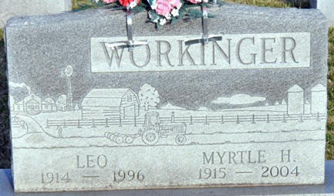
Photo by Deb Curry

Leo S Workinger
in the Indiana, U.S., Death Certificates, 1899-2017
Name Leo S Workinger
Gender Male
Race White
Marital Status Married
Age 81
Birth Date 30 Nov 1914
Birth Place Adams County, Indiana
Death Date 3 Mar 1996
Death Place Decatur, Adams, Indiana, USA
Death Registration Date 1996
Father Perry Workinger
Mother Ida May Gay
Spouse Myrtle Walters
Informant Myrtle Workinger; wife; Decatur, Indiana
Burial March 6, 1996; Decatur Cemetery; Decatur, Indiana

