Ida M. (Gay) Workinger
January 9, 1890 – December 2, 1958

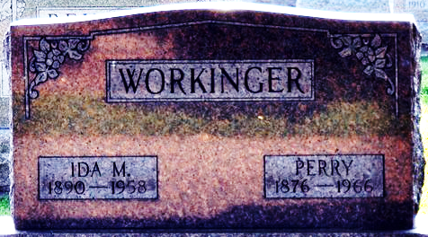
Photo by Deb Curry

MRS. IDA WORKINGER
Word has been received here by relatives of the death of Mrs. Ida Workinger, 70, of Wren, who died at noon Monday at her home.
Her husband, Perry Workinger, survives along with a son and a daughter.
Funeral services will be held at the Zwick Funeral Home in Decatur, Ind. Thursday afternoon. Burial will also be in Decatur Cemetery.

Lima News, Allen County, Ohio
Tuesday, December 2, 1958
**
Ohio, County Death Records, 1840-2001
Name Ida Workinger
Sex Female; Race White
Age 68y
Birth Date 09 Jan 1890
Birthplace Indiana
Residence Place Wren, Van Wert, Ohio
Burial Date 05 Dec 1958
Burial Place Decatur, Indiana
Marital Status Unknown
Father's Name George Gay
Mother's Name Sorelda Chronister
Death Date 02 Dec 1958
Death Place Wren, Willshire Township, Van Wert, Ohio, United States
Cemetery Decatur
Informant Perry Workinger; Ohio City, Ohio
Source Details item 18 cn 220

