Florence A. Workinger
April 11, 1884 – December 20, 1964

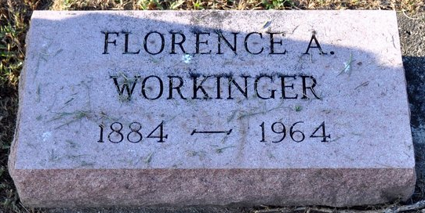
Photo by Deb Curry

OTTAWA – Florence A. Workinger, 80, a patient at Goedde Rest Home the past two years, died at 12:30 a.m. Sunday. She was born April 11, 1884 in Decatur, Ind., the daughter of Sam and Margaret (Hilliard) Workinger. For many years she lived at 1819 Clyde, Lima.
A member of Pilgrim Holiness Church, Lima, she is survived by a daughter, Mrs. George (Vivian) Fowler, 1643 Breese Rd., Lima; two grandchildren; seven great-grandchildren; and a brother, Perry, Fort Wayne.
Services will be at 10 a.m. Wednesday in Zwick Funeral Home, Decatur, with Rev. J. B. Zeits officiating. Burial will be in Decatur Cemetery. Initial arrangements were handled by LaPoint Funeral Home.

Lima News, Allen County, Ohio
Tuesday, December 22, 1964

