Edwin Bert Workinger
December 26, 1880 – April 5, 1952

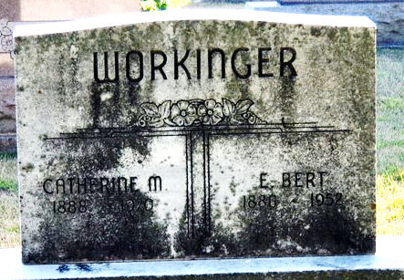
Photo by Deb Curry

E. B. WORKINGER DIES AT HOME IN HARRISON TOWNSHIP

E. B. Workinger, resident of Harrison Township since 1905, died unexpectedly following a heart attack Saturday at his home.
He is survived by his widow, Katherine; a son, Richard, and a daughter, Mrs. J. N. Friedly, both of Pontiac, Mich.; two brothers, Perry of Wren and Pierce of Greenville; two sisters, Mrs. Lawrence Johnson of Decatur, Ind., and Florence Workinger of Lima; and five grandchildren.
Rites will be conducted at 1:45 p.m. Tuesday at the Zwick Funeral Home in Decatur and at 2:30 p.m. at Pleasant View Baptist Church of which the deceased was a member. Rev. O. B. Turner will officiate and burial will be in Decatur Cemetery.

Van Wert Times Bulletin, Van Wert County, Ohio
Monday, April 7, 1952

**
Name: Edwin Bert Workinger
Event Type: Death
Event Date: 05 Apr 1952
Gender: Male
Age: 71
Race: White
Birth Date: 26 Dec 1880
Birthplace: Adams Co. Indiana
Birth Year (Estimated): 1881
Father's Name: Samuel Workinger
Mother's Name: Margaret Hilyard
Informant: Richard Workinger;
Burial: April 8, 1952; Decatur Cem., Decatur, Ind.
File Number: certificate
GS Film number: 2246297
Digital Folder Number: 004109422
Image Number: 02865
Citing this Record
"Ohio Deaths, 1908-1953," database with images, FamilySearch (https://familysearch.org/ark:/61903/1:1:X6L9-8ML: 15 August 2019), Margaret Hilyard in entry for Edwin Bert Workinger, 05 Apr 1952; citing, reference certificate; FHL microfilm 2,246,297.

