Catherine M. (Roth) Workinger
January 13, 1888 – April 21, 1970

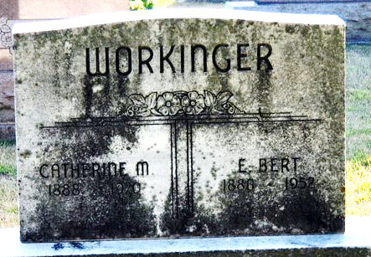
Photo by Deb Curry

MRS. CATHERINE WORKINGER

Mrs. Catherine Workinger, 82, a former resident of the Wren area, died at 7 p.m. Tuesday in William Beaumont Hospital, in Royal Oak, Michigan. She had been seriously ill for three weeks.
Born January 13, 1888, in Harrison Township, Van Wert County, she was the daughter of Fred and Lydia (Strouder) Roth. She was married September 10, 1905, to Edwin Burt Workinger, who died April 5, 1952.
Mrs. Workinger was a member of the Pleasant View Baptist Church at Wren.
Survivors include a daughter, Mrs. Helen Friedly of Pontiac, Mich., with whom she had resided for 14 years; five grandchildren and one great-grandson.
Funeral services will be conducted at 1:30 p.m. Saturday at the Zwick Funeral Home, Decatur; the Rev. O. B. Turner to officiate. Burial will be in the Decatur Cemetery. Friends may call at the funeral home after 7 p.m. today.

Van Wert Times Bulletin, Van Wert County, Ohio
Thursday, April 23, 1970
**
Mrs. Workinger Dies in Michigan
Mrs. Catherine Workinger, 82, of 2340 Winkleman Drive, Pontiac, Mich., a former resident of east of Decatur, died at 7 p.m. Tuesday at the William Beaumont Hospital in Royal Oak, Mich. She had been seriously ill for three weeks.
She had lived with her daughter at Pontiac for the past 14 years.
She was born in Harrison Township, Van Wert County, O., Jan. 13, 1888, a daughter of Fred and Lydia Strouder-Roth, and was married to Edwin (Bert) Workinger Sept. 10, 1905. Her husband preceded her in death April 5, 1952.
Mrs. Workinger was a member of the Pleasant View Baptist Church at Wren, O.
Surviving is the daughter, Mrs. Helen Friedly of Pontiac; five grandchildren, and one great-grandson.
Funeral services will be conducted at 1:30 p.m. Saturday at the Zwick Funeral Home, with Rev. O. B. Turner officiating. Burial will be in the Decatur Cemetery. Friends may call at the funeral home after 7 p.m. Thursday until time of the services.

Decatur Daily Democrat, Adams County, Indiana
Thursday, April 23, 1970

**
U.S., Social Security Death Index, 1935-2014

Name: Catherine Workinger
Social Security Number: xxx
Birth Date: 13 Jan 1888
Issue year: Before 1951
Issue State: Indiana
Last Residence: 48055, Pontiac, Oakland, Michigan, USA
Death Date: Apr 1970

