James C. Worden
June 11, 1874 – March 7, 1960

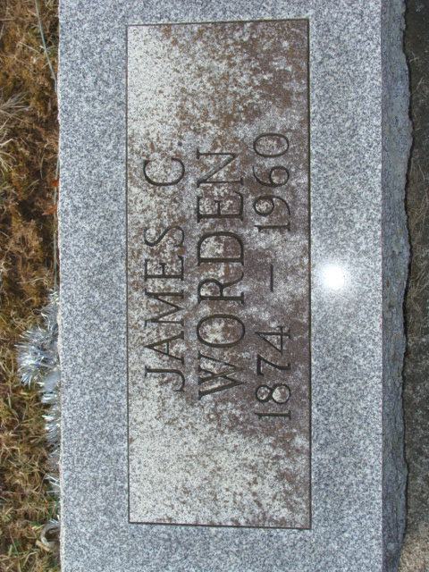
Photo by Alicia Kneuss

Janes C Worden
in the Indiana, Death Certificates, 1899-2011
Name: Janes C Worden
Gender: Male
Race: White
Age: 83
Marital status: Married
Birth Date: 11 Jun 1874
Birth Place: Adams Co, Indiana
Death Date: 7 Mar 1960
Death Place: Decatur, Adams, Indiana, USA
Father: George Worden
Informant: Arthur Worden; son; Fort Wayne, Indiana
Burial: March 9, 1960; Decatur Cemetery; Decatur, Indiana

