Clara Louise (Linn) Worden
April 11, 1875 – January 16, 1967

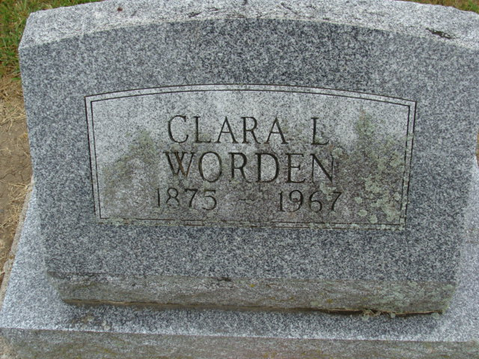
Photo by Alicia Kneuss

Clara Louise Worden
in the Indiana, Death Certificates, 1899-2011
Name: Clara Louise Worden
[Clara Louise Linn]
Gender: Female
Race: Caucasian (White)
Age: 91
Marital status: Widowed
Birth Date: 11 Apr 1875
Birth Place: Pennsylvania
Death Date: 16 Jan 1967
Death Place: Bluffton, Wells, Indiana , USA
Father: Daniel Linn
Mother: Louise Miller
Informant: Mrs. Evelyn C??; granddaughter; Monroe, Ind.
Burial: Jan. 19, 1967; Decatur Cem., Decatur, Ind.

