George Wesley Woodward
July 5, 1848 – January 22, 1904

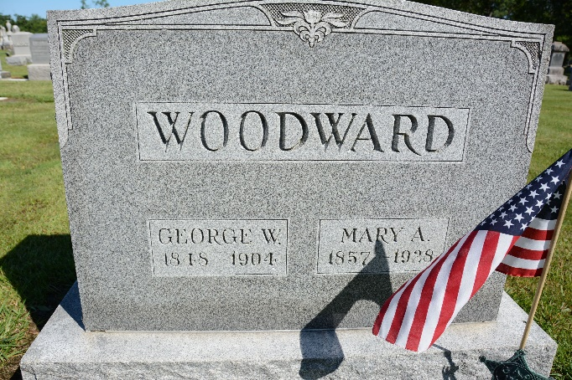
Photo by Deb Curry

George Wesley Woodward
in the Indiana, U.S., Death Certificates, 1899-2017
Name George Wesley Woodward
Gender Male
Race White
Marital Status Married
Age 55
Birth Date 5 Jul 1848
Birth Place Ohio Muskingdams
Death Date 22 Jan 1904
Death Place Decatur, Adams, Indiana, USA
Death Registration Date 1904
Father Asa Woodward
Mother Mary Ann Hart
Spouse Mary A
Informant James O. Ball; Decatur, Indiana
Burial January 25, 1904; Decatur Cemetery

