Jane (Elzey) Woods
August 9, 1833 – November 18, 1917

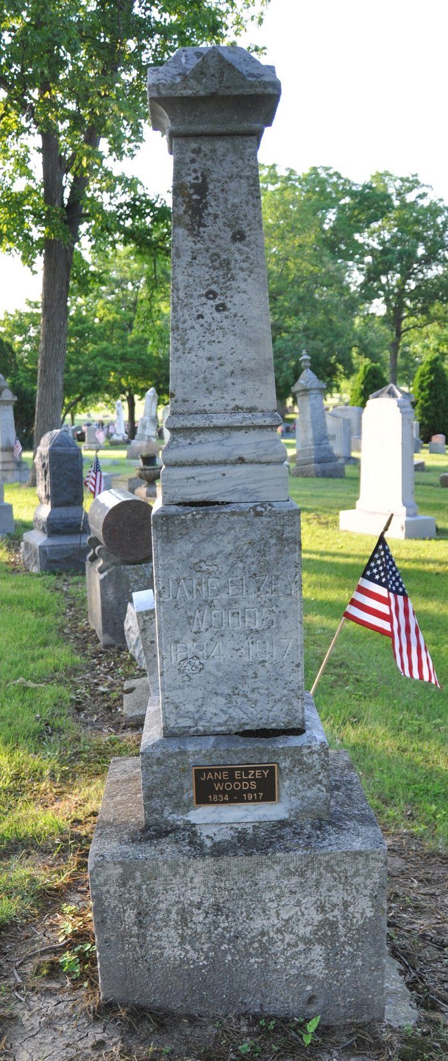
Photo by Deb Curry

MRS. WOODS DEAD - Jane Elxey [sic] Woods, Widow of E. Woods, Passed Away AT HER HOME - On West Monroe Street - Was Ill Several Months
In the death of Mrs. James [sic] Elzey Woods, widow of E. Woods, which occurred Sunday morning at one o'clock at her home on West Monroe street, the city loses one of its best known elderly ladies. Mrs. Woods was eighty-four years, four months and nine days of age. Death was due to a complication of asthma and Bright's disease.
Mrs. Woods had been in failing health for several months, but she showed remarkable vitality, in combating the onslaught of infirmity, and it was not until in the past few weeks that the decline, which gradually persisted, began to seriously tell on her.
She was born August 9, 1833, in Blanchester, O., where her girlhood days were spent. Later she came with her parents, James and Mary Elzey, to Adams County and all of her later life was spent here.
She was married in young womanhood to Emanuel Woods who departed this life several years ago.
Surviving children are: Mrs. Minnie Wilkinson, Decatur; Florence, wife of Eli Meyer, Fort Wayne; Jennie, wife of J. C. Polhemus, Upper Sandusky, O.; Hugh Woods, of Warsaw. Of her parental family, but two are living, being a brother, E. Elzey of Ossian and a brother, Franklin Elzey, of Monroe. Six are dead.
Mrs. Woods was a member of the Methodist Church. The Rev. F. F. Thornburg will officiate at the funeral services which will be Tuesday afternoon at two o'clock from the home on West Monroe Street with burial in the Decatur Cemetery.
Decatur Daily Democrat; Adams County, Indiana
Monday, November 19, 1917
**
Indiana, U.S., Death Certificates, 1899-2011
Name: Jane Elzey Woods
Gender: Female
Race: White
Age: 84
Birth Date: 9 Aug 1833
Birth Place: Ohio
Death Date: 18 Nov 1917
Death Place: Decatur, Adams, Indiana, USA
Father: James Elzey
Mother: Mary Camp
Spouse: Emanuel Woods
Informant: Hugh Woods; Warsaw, Indiana
Burial: November 20, 1917; Decatur Cemetery

