Emanuel Woods
August 5, 1833 – June 5, 1914

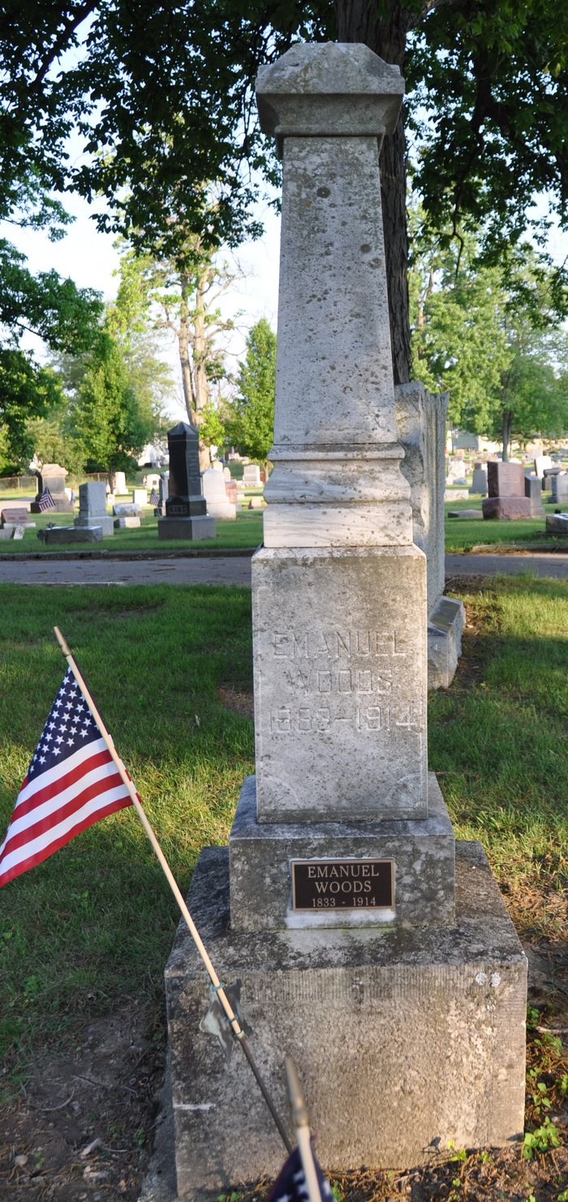
Photo by Deb Curry

VETERAN IS DEAD - Emanuel Woods, Pioneer of Adams County, Passes Away Last Night AT ELEVEN O'CLOCK
Was One of the Highest Esteemed Men in the County; Ill Many Months
Once more in the eternal cycle of life with its varying shades of emotion, has the angel of death cast its shroud of sorrow over Adams County residents and caused to depart from its earthly home to mansions in the sky prepared by the Father, the spirit of that most illustrious citizen, Emanuel Woods.
Possibly no other resident of Adams was so popular and universally esteemed as was Mr. Woods and his demise brings sorrow to the hearts of all who enjoyed his acquaintance. For sixty-one years, Mr. Woods has been a resident of Adams County and ever will its people hold his memory with the highest of respect as one of the pioneers through whose untiring endeavors and ceaseless efforts brought this county to its present standard of attainment.
Mr. Woods was born at Applecreek, Ohio, on August 8, 1833, being the son of John and Jane Woods. He resided at his birth place until nineteen years of age, gaining his early knowledge and experience in life there, and in 1852 moved with his parents to Adams County. In 1855 he was united in marriage to Miss Jane Elzey of this city, and who now survives to mourn his departure together with three daughters, Mrs. Wilkinson, Mrs. Eli Meyers and Mrs. Polhemus, of Ft. Wayne, and one son, Hugh, now a resident of Warsaw, Indiana. Two children also preceded the father in death, they being, Alice Victoria and Marietta. Mr. Woods was the last of his immediate family, all sisters and brothers, with the parents, having preceded him to the eternal home.
His illness has been of several years' duration, but not until last year did it become serious. In October, 1913, he entered a hospital at Fort Wayne for removal of bladder stones. He rallied from this operation successfully and was thought to be improving nicely. Nine weeks ago, however, he was forced to take to his bed, and a steady decline was noticed until death relieved him last night at 11 o'clock, being caused from uremic poisoning.
Not only was Mr. Wood popularly known throughout Adams County, but over a large territory where his business of contracting called him.
He was a member of the G.A.R. and a loyal christian worker in the Methodist Church of this city. The funeral will be held at the home Monday afternoon at 2 o'clock and will be in charge of Rev. Stephenson and also the G.A.R. Interment will be held in Maplewood Cemetery.
MILITARY RECORD
The following military record has been contributed by R. Blackburn.
At the call in July, 1862, for three hundred thousand volunteers, the Rev. Enos W. Erick commenced recruiting a company. Among the first to enlist was Emanuel Woods of this city. The company was organized on August 9, 1862, and was known as Company H, 89th Indiana. At the organization of the regiment, Comrade Woods was appointed regimental wagon master. In the month of December, 1862, he was exposed to the mumps and measles which unfit him for any military duty to a degree that caused him to be discharged in the early spring of 1863. As a soldier, Comrade Woods was always ready for any emergency.
Decatur Daily Democrat; Adams County, Indiana
Saturday, June 6, 1914
**
Indiana, U.S., Death Certificates, 1899-2017
Name Emanuel Woods
Gender Male
Race White
Marital Status Married
Age 80
Birth Date 5 Aug 1833
Birth Place Ohio
Death Date 5 Jun 1914
Death Place Decatur, Adams, Indiana, USA
Death Registration Date 1910-1919
Father John Woods
Mother Elizabeth Brown
Spouse Jane Elzey
Informant Florence Meyer; Decatur, Indiana
Burial June 8, 1914; Decatur Cemetery

