Alice V. Woods
August 26, 1856 – December 24, 1856

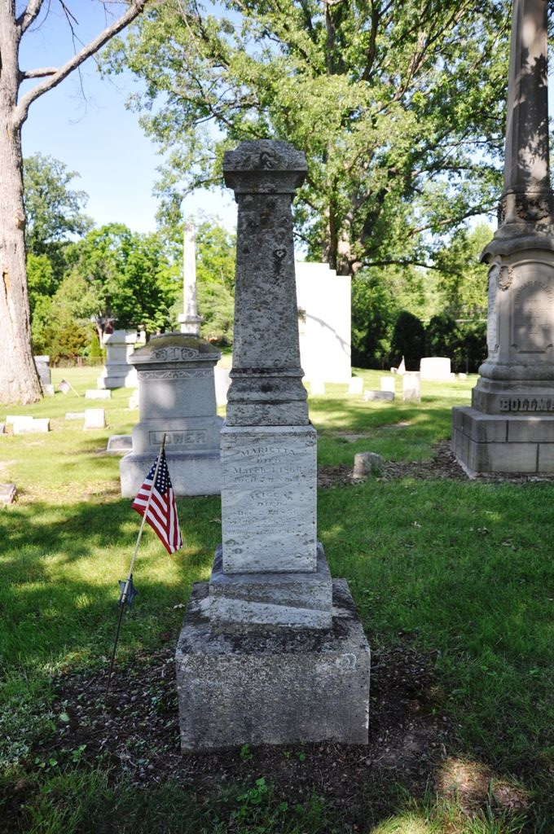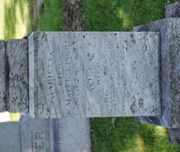
Photo by Deb Curry

From Maplewood burials, Adams County Public Library:
Woods, Alice V., died December 24, 1856, age 3 mo. 28 da.
**
Alice Woods from tree Zimmerman/Bender Family Tree
Birth 26 Aug 1856 Indiana, USA
Death 24 Dec 1856 Decatur, Adams, Indiana, USA
Father Emanuel Woods (1833-1914)
Mother Jane Elzey (1833-1917)

