Nora Loretta (Huffman) Woodruff
June 20, 1887 – May 23, 1971

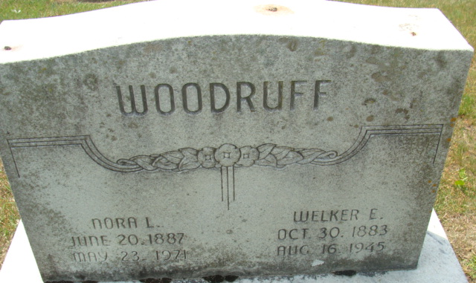
Photo by Alicia Kneuss

Nora Lorotta Woodruff
in the Indiana, U.S., Death Certificates, 1899-2017
Name Nora Loretta Woodruff
[Nora Loretta Huffman]
Gender Female
Race White
Marital Status Widowed
Age 83
Birth Date 20 Jun 1887
Birth Place Indiana
Death Date 23 May 1971
Death Place Decatur, Adams, Indiana, USA
Death Registration Date 1971
Father George Huffman
Mother Rcsan Dodge
Informant Mrs. Arthur Daniels; daughter; Decatur, Indiana
Burial May 26, 1971; Decatur Cemetery; Decatur, Indiana

