Julia Jane (Andrews) Woodruff
November 29, 1917 – March 24, 1943

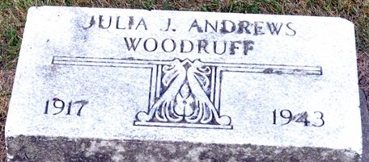
Photo by Deb Curry

Mrs. Glen Woodruff Dies Suddenly Today
Decatur Young Lady is Taken by Death
Mrs. Julia J. Andrews-Woodruff, 25, of North Second Street, wife of Pvt. Glen C. Woodruff, died suddenly at 5:30 o’clock this morning at Memorial Hospital. Death was attributed to an aneurysm.
Mrs. Woodruff was taken to the hospital March 12, where a son was born by caesarian section. His condition was reported excellent.
She was born in Washington Township November 19, 1917, the daughter of Charles A. and Stella Jane Andrews, with whom she had made her home since her husband entered the U.S. Army.
She was married to Glen G. Woodruff in August, 1935. He is now stationed at Atlantic City, N.J. She attended Decatur High School and was formerly employed at the General Electric Works here.
Surviving are the husband, the infant son, Glen Allen; the parents and the following brothers and sisters; Mrs. Richard Lessing of Kalamazoo, Mich.; Mrs. Ray Osterman of Harrisburg, Pa.; Charles Jr, Charlotte, Evelyn, Geraldine and Joan Andrews, all at home.
Funeral arrangements have not been completed. The body was removed to the Zwick Funeral Home.

Adams County Historical Museum, Adams County, Indiana
1943B Scrapbook, image 33
Wednesday, March 24, 1943
**
Woodruff Funeral Saturday Afternoon

Funeral services for Mrs. Glen G. Woodruff, who died suddenly Wednesday morning, will be held at the home of her parents, Mr. and Mrs. Charles A. Andrews, North Second Street, Saturday afternoon at 3 o’clock. Rev. Paul Brandyberry of Garrett, former pastor of the Decatur Church of the Nazarene, will officiate and burial will be in the Decatur Cemetery. The body was removed from the Zwick Funeral Home to the residence this afternoon.

Adams County Historical Museum, Adams County, Indiana
1943B Scrapbook, image 33
Wednesday, March 25, 1943

**
Indiana, U.S., Death Certificates, 1899-2017
Name Mrs Julia Jane Woodruff
[Mrs Julia Jane Andrews]
Gender Female
Race White
Marital Status Married
Age 25
Birth Date 29 Nov 1917
Birth Place Washington Twp Adams Colorado
Death Date 24 Mar 1943
Death Place Decatur, Adams, Indiana, USA
Death Registration Date 1943
Father Charles A Andrews
Mother Stella Jane Barber
Spouse Glen Woodruff
Informant Mrs. Chas. Andrews; Decatur, Indiana
Burial March 27, 1943; Decatur Cemetery; Decatur, Indiana

**
Andrews
in the Indiana, U.S., Birth Certificates, 1907-1944
Name Andrews
Gender Female
Birth Date 29 Nov 1917
Birth Place Monroe, Adams, Indiana, USA
Father Charlie Andrews; age 31
Mother Estella Barber; age 26; 3rd child, all living
Certificate Number 464
Roll number 45385_539563
Volume Range 1108 - 1111

