Demas M. Woodruff
March 11, 1820 – January 1, 1864

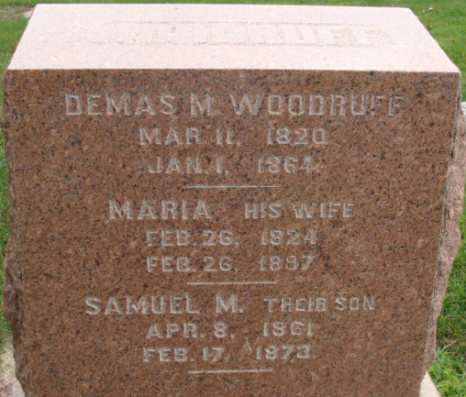
Photo by Alicia Kneuss

Demas M Woodruff from tree Astuto/Morrison Jenkins/McBath Family Line
Birth 11 Mar 1820 New Jersey, USA
Marriage 25 Feb 1844 Greene, Pennsylvania, USA
Residence 1860 Washington, Greene, Pennsylvania, USA
Death 1 Jan 1864 New Brighton, Beaver, Pennsylvania, USA
Father Joshua Woodruff (Born 1798)
Mother Mary Martin (1801-1879)
Spouse Mary Maria Mitchell (1824-1897)

**
DEMAS M. WOODRUFF, deceased, was born in Greene County, Pennsylvania, March 11, 1820, a son of Joshua Woodruff, a native of Maine, of English descent. He was reared in his native county, and was there married February 25, 1844, to Maria Mitchell, a native of the same county, born February 26, 1824.
October 23, 1863, he moved to Adams County, Indiana, and bought 120 acre of land in St. Mary's Township. A few weeks later he returned to Pennsylvania to settle up his business interests there, and when on his way home was killed in a railroad collision at New Brighton, Pennsylvania, January 1, 1864.
Mr. and Mrs. Woodruff had a family of seven children; five are living - Thomas M., born May 20, 1845; Reuben M., born February 8, 1847; Lucy J., born March 23, 1849; Violetta J., born July 14, 1855, died June 28, 1857; Mary V., born February 25, 1857; Andrew J., born July 14, 1859; Samuel M., born April 8, 1861 and died February 17, 1873.
In politics Mr. Woodruff was a Democrat. Mrs. Woodruff is a daughter of Thomas and Sarah (Mitchell) Mitchell, her father born in New Jersey and her mother in Greene County, Pennsylvania. Her father was killed in a sugar camp by the falling of a tree, January 10, 1827, and June 20, 1830, her mother married Abner Tharp. She had a family of ten children, six by her first marriage, and four by second. Mrs. Woodruff is a member of the Christian church, in which she is a faithful and earnest worker.

Biographical and Historical Record - Adams and Wells Co. Indiana Lewis Publishing Co. Chicago, IL 1887

