Gracie Lee (Carter) Womack
May 11, 1891 – April 10, 1920

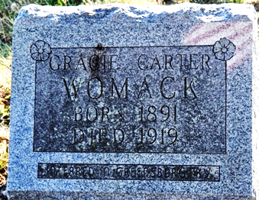
Photo by Alicia Kneuss

Grace Lee Womach
in the Indiana, U.S., Death Certificates, 1899-2017
Name Grace Lee Womack
[Grace Lee Carter]
Gender Female
Race White
Marital Status Married
Age 27
Birth Date 11 May 1891
Birth Place Kentucky
Death Date 10 Apr 1920
Death Place Decatur, Indiana, USA
Father Calvin Carter
Mother Jane Faubush
Spouse Burg Womack
Informant G. W. Ogg; Decatur, Indiana
Burial April 15, 1920; ?? Boone, Kentucky

