George C. Womack, Sr.
October 15, 1912 – April 16, 1992

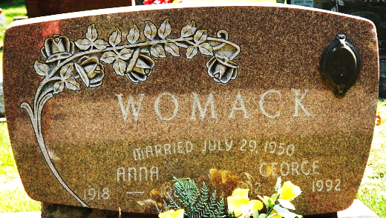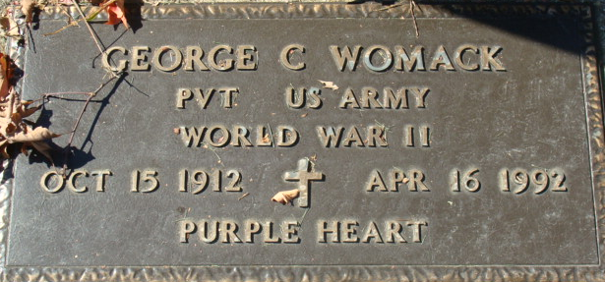
Photo by Deb Curry

George C. Womack, Sr., 79, of Decatur died yesterday in Adams County Memorial Hospital.
The Greensburg, Ky., native retired in 1975 from General Electric Co. after 45 years and received a purple heart during World War II. His wife, Anna, died in 1984.
Surviving is a daughter, Georgiann Maloney of Decatur; son, George C. Jr. of Decatur; a grandchild; and a step grandchild.
Services are 10 a.m. Monday in Calvary Chapel. Calling is 2 to 5 and 7 to 9 p.m. tomorrow, and 6 to 9 p.m. Sunday in Zwick-Sefton & Jahn Funeral Home, Decatur, and 9 to 10 a.m. Monday in the church. Burial will be with military honors in Decatur Cemetery.
Preferred memorials are gifts to Adams County Crippled Children and Adults Inc.

News-Sentinel, Allen County, Indiana
Friday, April 17, 1992
**
Indiana, U.S., Death Certificates, 1899-2017
Name George C Womack
Gender Male
Race White
Marital Status Widowed
Age 79
Birth Date 15 Oct 1912
Birth Place Greensburg, Kentucky
Death Date 16 Apr 1992
Death Place Decatur, Adams, Indiana, USA
Death Registration Date 1992
Father Berg Womack
Mother Gracie Carter
Informant George C. Womack, Jr.; son; Decatur, Indiana
Burial April 20, 1992; Decatur Cemetery; Decatur, Indiana

