Burg Calvin Womack
August 9, 1877 – September 9, 1946

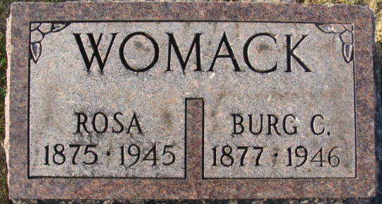
Photo by Alicia Kneuss

Burg Womack Dies Suddenly Monday
Retired Policeman Is Taken By Death
Burg Womack, 69, former Decatur police officer, died suddenly Monday evening at the home of a daughter, Mrs. Elisa Gause, Orland, where he had been visiting for a few days.
He was born in Greensburg, Ky. August 9, 1877. and had made his home in Decatur since 1922. The family resides at 816 Line Street.
He was a member of the Nuttman Avenue United Brethren Church.
His wife, Rosa, died July 17, 1945.
Surviving are two daughters. Mrs. Ray Eicher of Decatur and Mrs. Gause; two sons, George Womack of Decatur and Woodson Lee Womack, with the army at Fort Worth, Tex.; one brother, Richard Womack of Logan, Utah; one sister, Mrs. Ida Ogg of Decatur; a half-sister. Mrs. Adolph Baumann of Decatur, and seven grandchildren.
Funeral arrangements have not been completed. The body will be brought to the Zwick Funeral Home in this city.
Decatur Daily Democrat; Adams County, Indiana
Tuesday, September 10, 1946
**
Burgynay Calvin Womack from tree 2024 Womack / Richeson
Birth 15 Aug 1877 Adair, Hancock, Kentucky, USA
Marriage 9 Sep 1920 Allen, Indiana, USA
Residence 1940 Decatur, Adams, Indiana, USA
Death 9 Sep 1946
Father John Dudley Womack (1844-1923)
Mother Mary Ann Stinson (1848-1896)
Spouse Grace Lee Carter (1891-1920)

