Anna (Ivetich) Womack
September 28, 1918 – December 4, 1984

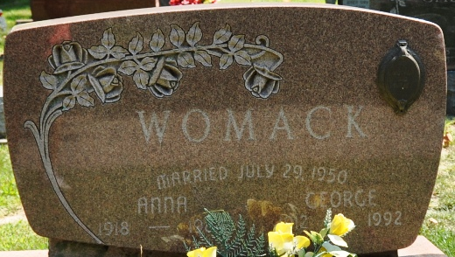
Photo by Deb Curry

Anna Womack
in the Indiana, U.S., Death Certificates, 1899-2017
Name Anna Womack
[Anna Ivetich]
Gender Female
Race White
Marital Status Married
Age 66
Birth Date 28 Sep 1918
Birth Place Indiana
Death Date 4 Dec 1984
Death Place Indiana, Bluffton, Indiana, USA
Death Registration Date 1984
Father James Ivetich
Mother Helen Zivider
Spouse George C. Womack
Informant George Womack; husband; Decatur, Indiana
Burial December 8, 1984; Decatur Cemetery; Decatur, Indiana

