William Addison Wolfe
December 9, 1867 – February 23, 1954

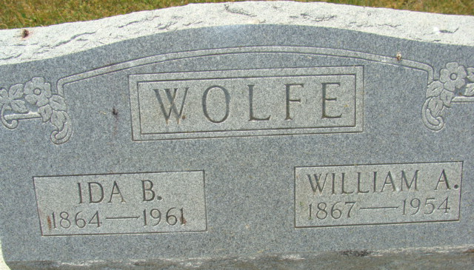
Photo by Alicia Kneuss

WOLFE
DECATUR, Ind. – William Addison Wolfe, 86, retired laborer, died Tuesday at his home in Decatur after a weeks' illness. He was a native of Ohio, but lived in Decatur 25 years.
Surviving are his widow, Ida; two daughters, Mrs. Nora Wolfe of Harrison Township and Mrs. Charlotte Ladd of Decatur; two brothers, David Wolfe of Decatur and John Wolfe of Ohio; a sister, Mrs. Anna Uhrich of Ohio City and 21 grandchildren.
Rites will be held at 2 p.m. (CST) Thursday at the Black Funeral Home and burial will be in Decatur Cemetery.

Van Wert Times Bulletin, Van Wert County, Ohio
February 24, 1954

**
Indiana, Death Certificates, 1899-2011
Name: William Addison Wolfe
Gender: Male
Race: White
Age: 86
Marital status: Married
Birth Date: 9 Dec 1867
Birth Place: Willshire, Ohio
Death Date: 23 Feb 1954
Death Place: Decatur, Adams, Indiana , USA
Father: David Wolfe
Informant: Mrs. Wm. A. Wolfe; Decatur, Ind.
Burial: Feb. 25, 1954; Decatur Cem.

