W. Clarence Wolfe
March 20, 1905 – September 15, 1969

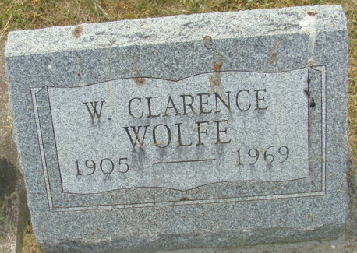
Photo by Alicia Kneuss
CLARENCE WOLFE
DECATUR, Ind. – Clarence Wolfe, 64, of Decatur, a former employee of the Yost Construction Co., died at 9:35 p.m. Monday in the Adams County Memorial Hospital following an extended illness.
A native of Wren, Ohio, he was born March 20, 1905, the son of Davis and Norah Wolfe. His mother survives and lives in Decatur. Mr. Wolfe retired in 1955 due to ill health.
In addition to his mother, surviving are four brothers, including Junior of Willshire, and two sisters.
Friends may call at the Zwick Funeral Home, where services will be at 1:30 p.m. Thursday with the Rev. Robert VanderHart officiating. Burial will be in Decatur Cemetery.

Van Wert Times Bulletin, Van Wert County, Ohio
September 17, 1969

**
Clarence Wolfe Dies Monday

Clarence Wolfe, 64, of 634 Kekionga Street, died at 9:35 p.m. Monday evening in the Adams County Memorial Hospital. He had been ill for 14 years.
A native of Wren, O., he was born March 20, 1905, the son of Davis and Norah Myers Wolfe. His mother survives and is living in Decatur.
Mr. Wolfe was a former employee of the Yost Construction Co., until 1955, when he retired because of poor health.
In addition to his mother, survivors include two sisters, Mrs. Russel (Pearl) Miller, and Mrs. Jake (Lulu) Shaffer, both of Decatur; Harold, of Muncie; James of Maricopa, Calif.; and Junior Wolfe of Route One, Willshire, O.
The body was taken to the Zwick Funeral Home, where friends may call after 7 p.m. this evening. Funeral services will be held at 1:30 p.m. Thursday at the Zwick Funeral Home, the Rev. Robert VanderHart officiating. Burial will be in the Decatur Cemetery.
Decatur Daily Democrat, Adams County, Indiana
Tuesday, September 16, 1969

**
Indiana, U.S., Death Certificates, 1899-2017
Name Clarence Wolfe
Gender Male
Race White
Age 64
Marital Status Divorced
Birth Date 20 Mar 1905
Birth Place Decatur
Death Date 15 Sep 1969
Death Place Decatur, Adams, Indiana, USA
Death Registration Date 1969
Father: Davis Wolfe
Mother: Norh Myers
Informant: Mrs. Davis Wolfe; mother; Decatur, Indiana
Burial: September 18, 1969; Decatur Cemetery; Decatur, Indiana

