Sarah Ellen (Moore) Wolfe
April 22, 1857 – June 25, 1928

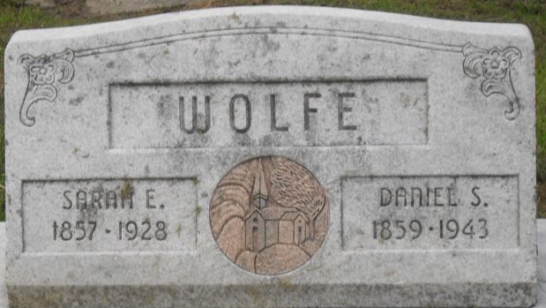
Photo by Alicia Kneuss

SARAH E. WOLF CALLED BY DEATH
Wife Of Dan Wolf Dies At Home In Washington Township Monday Night
Mrs. Sarah Ellen Wolf, 71, wife of Dan Wolf, of Washington Township, Adams County, died at her home at 11:30 o’clock last night, Monday, June 25, 1928, after a four years illness, believed to have resulted from cancer.
The deceased was born April 22, 1857 at Amanda, Fairfield County, O.. and was the daughter of Mr. and Mrs. Anthony Moore. She united in marriage with Dan Wolf. Six children who survive, as a result of this union, are: Mrs. Nellie Gould, of Warren, Ohio, Clyde Wolf, residing east of Monroe, Mrs. Ollie Durbin, of Fort Wayne, Mrs. Lora Strickler, of Decatur, Mrs. Virgie Carver, of Fort Wayne and Harry Wolf of this city.
Three surviving sisters and one brother are; Mrs. Ollie Gortner, of Columbus, Ohio; Mrs. Della Waites, Lancaster, Ohio; Mrs. Melton Moore, Chillicothe. Ohio, and Mr. John Moore, of Lancaster, Ohio.
Mrs. Wolfe has resided in Indiana for the last forty-four years. She was a member of the Pleasant Valley Friends Church.
Funeral services will be held at 1:30 at the residence, and at 2 o’clock at the Pleasant Valley Church. Rev. LesLe McCorger will officiate at the services. Burial in Decatur Cemetery.
Decatur Daily Democrat; Adams County, Indiana
Tuesday, June 26, 1928

