Robert L. Wolfe
December 12, 1934 – October 30, 2013

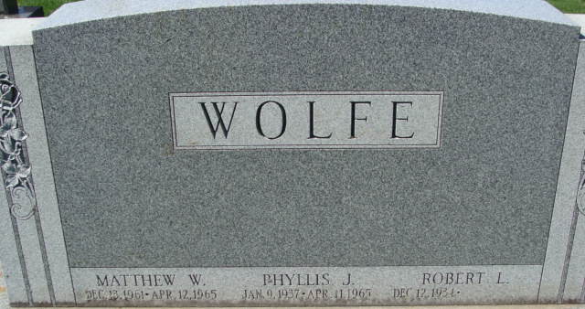
Photo by Alicia Kneuss

Robert L. Wolfe, 78, of Decatur, IN died at his residence on Wednesday, October 30, 2013. Robert was born in Decatur, IN on December 12, 1934 to the late Cloyce and Helen (Blazer) Wolfe. He married Phyllis J. Rankins in December of 1955. She preceded him in death in 1965.
Robert retired from Central Soya with over 40 years of service.
He is survived by two sons, Mitchel Wolfe and Michael Wolfe of Decatur; two daughters, Gail (Randy) McAllister of Texas and Gwen Reynolds of Decatur; a sister Marjorie Schlemmer of Ohio; 4 grandchildren and 8 great grandchildren. He is preceded in death by a son Matthew Wolfe and a sister Beatrice Hess.
Per family's request, there are NO SERVICES. Burial will be in Decatur Cemetery at a later date.

Unknown source

