Phyllis J. (Rankins) Wolfe
January 9, 1937 – April 11, 1965

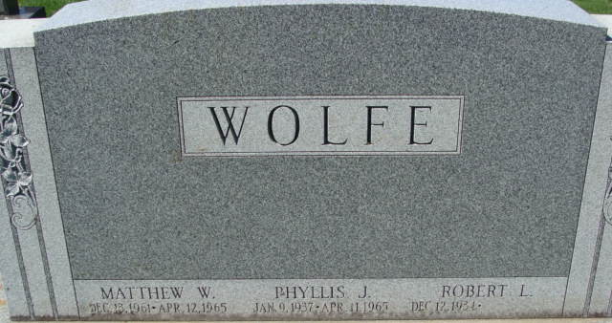
Photo by Alicia Kneuss

TRAGEDY HAUNTS THREE-COUNTY STORM AREA
Volunteers Clear Tornado Debris

Mitchel Wolfe, 7, of Rt. 1, Rockford, today was reported in critical condition in Parkview hospital, Fort Wayne. His mother, Mrs. Robert Wolfe, 29, and a brother, Matthew, 4, were killed when the tornado demolished their home in northwest Mercer County. The father and two other children were treated for minor injuries in Decatur, Ind. hospital.
Funeral services for Mrs. Phyllis Wolfe, 28, and her 4-year-old son Matthew of Rt. 1, Rockford, are pending at the Zwick Funeral Home, Decatur, Ind.

Lima News, Allen County, Ohio
Tuesday, April 13, 1965

**
Indiana, U.S., Death Certificates, 1899-2017
Name Phyllis Wolfe
[Phyllis Rankins]
Gender Female
Race Caucasian (White)
Marital Status Married
Age 28
Birth Date 9 Jan 1937
Birth Place Illinois
Death Date 11 Apr 1965; tornado
Death Place Decatur, Adams, Indiana, USA
Death Registration Date 1965
Father Clem R Rankins
Mother Dorothy M Eskew
Spouse Robert L Wolfe
Informant Robert L. Wolfe; husband; Willshire, Ohio
Burial April 15, 1964; Decatur Cemetery; Decatur, Indiana

