Nora V. (Meyers) Wolfe
May 18, 1883 – February 10, 1971

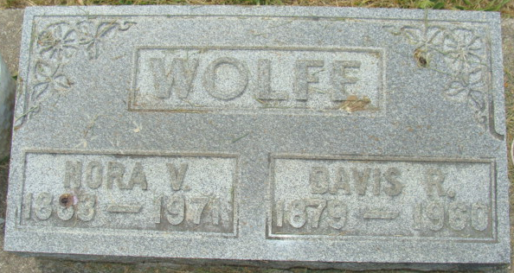
Photo by Alicia Kneuss

Mrs. Norah Wolfe is taken by Death
Mrs. Norah V. Wolfe, 87, of 634 Kekionga Street, widow of Dave Wolfe, died at 6:15 p.m. Wednesday at the Adams County Memorial Hospital. She had been ill since Saturday, and hospitalized only one day.
She was born in Van Wert County, O., May 18, 1883, a daughter of Sylvester and Ida Furlick-Meyers. Her husband, Dave Wolfe, preceded her in death April 9, 1960.
Surviving are two daughters, Mrs. Russel (Pearl) Miller and Mrs. Jake (Lula) Shaffer, both of Decatur; four sons, Cloyce R. Wolfe of Decatur, Junior Wolfe of Willshire, O., route 1, Harold Wolfe of Muncie and James Wolfe of Maricopa, Calif.; 46 grandchildren; 86 great-grandchildren, and two great-great-grandchildren. Three sons, George Virgil, Clarence and Arden are deceased.
Funeral services will be conducted at 1:30 p.m. Saturday at the Zwick Funeral Home, with Rev. Leonard Smith officiating. Burial will be in the Decatur Cemetery. Friends may call at the funeral home after 7 p.m. today until time of the services.
Decatur Daily Democrat, Adams County, Indiana
Thursday, February 11, 1971

