Joyce Sue (Cagle) Wolfe
July 1, 1935 – October 1, 2019

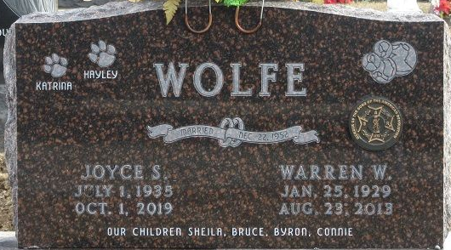
Photo by PLS

Joyce Sue Wolfe, 84, of Decatur, Indiana passed away at Lutheran Hospital on October 1, 2019. She was born in Waverly, TN on July 1, 1935 to the late Barney A. Cagle and Grace (O’Guin) Cagle. On December 22, 1952 she married Warren W. Wolfe. He passed away on August 23, 2013.
She was a member of the First Baptist Church where she served as a Deaconess. Joyce retired from CTS of Berne in 1998 after 25 years of service. She was also a member of the American Legion Post #43 Ladies Auxiliary and sold Avon upon her retirement.
Joyce is survived by 2 sons, Byron E. (Julie) Wolfe of Katy, TX and Bruce E. (Leesia) Wolfe of Clever, MO; 2 daughters, Sheila (Dave) Schnitz and Connie (Mike) Snyder both of Decatur, IN; 3 sisters, Roxie L. Little, Ruby J. Runions and Wilda Faye “Bill” Page all of Waverly, TN; 10 grandchildren and 25 great grandchildren. She was preceded in death by 2 brother and 2 sisters.
Burial at the Decatur Cemetery.

Unknown source

