Ida Belle (Fralick) Wolfe
February 14, 1864 – August 16, 1961

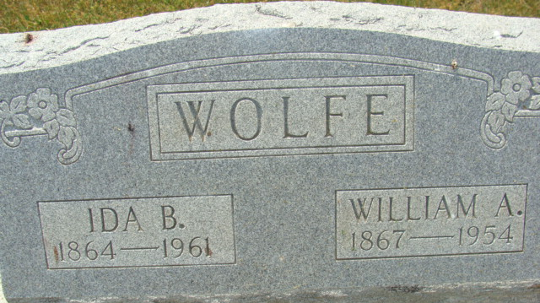
Photo by Alicia Kneuss

Mrs. Ida Wolfe, 97, Dies This Morning
Mrs. Ida Belle Wolfe, 97-year-old Decatur lady, died at 11 o'clock this morning at her home, 504 Elm Street. She had been in ill health for two years and in critical condition for the past two weeks.
She was born in Harrison township, Van Wert County, O., Feb. 14, 1864, a daughter of George and Lydia Fraylick. Her husband, Addison Wolfe, preceded her in death Feb. 23, 1954.
Surviving are two daughters. Mrs. Charlotte Stevens of Decatur, and Mrs. Nora Wolfe of Ohio; 12 grandchildren; 55 great-grandchildren, and 49 great-great-grandchildren.
Funeral services will be conducted at 2 p.m. Saturday at the Black Funeral Home, with burial in the Decatur Cemetery. Friends may call at the funeral home after 2 p.m. Thursday until time of the services.
Decatur Daily Democrat, Adams County, Indiana
Wednesday, August 16, 1961
**
Ida Belle Fralick from tree Miller Family Tree
Birth 14 Feb 1865 Middlebury, Knox, Ohio, USA
Marriage 7 Dec 1899
Residence 1940 Decatur, Adams, Indiana, USA
Death 16 Aug 1961 Decatur, Indiana, USA
Father George Washington Fralick (1832-1912)
Mother Lydia Sheets (1842-1910)
Spouse Sylvester Meyers (1867-1928)
Spouse William Addison Wolfe (1867-1954)

